1. Even or Odd Number
Write a program to check whether a number is even or odd using if-else.
Example:
Input: 7
Output: Odd
Code:
import java.util.Scanner;
class Main {
public static void main(String[] args) {
Scanner sc = new Scanner(System.in);
int num = sc.nextInt();
if (num % 2 == 0)
System.out.println("Even");
else
System.out.println("Odd");
sc.close();
}
}
Screen Shot:
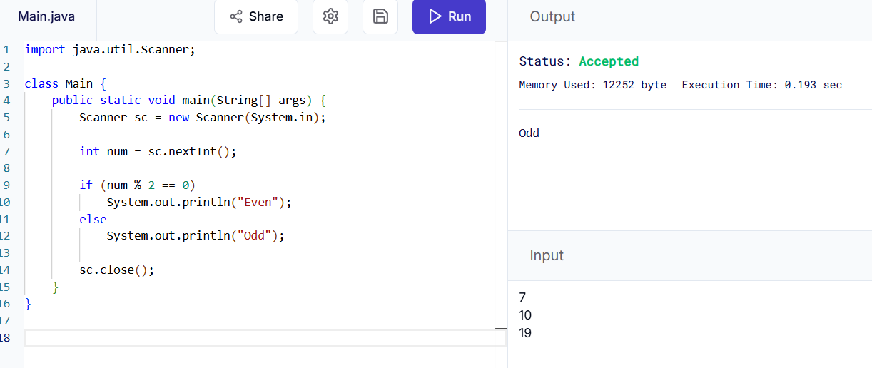2. Largest of Three Numbers
Write a program to find the largest among three numbers using nested if-else.
Example:
Input: 10 25 15
Output: 25 is largest

Code:
import java.util.Scanner;
public class LargestThree {
public static void main(String[] args) {
Scanner sc = new Scanner(System.in);
int a = sc.nextInt();
int b = sc.nextInt();
int c = sc.nextInt();
if (a > b) {
if (a > c)
System.out.println(a + " is largest");
else
System.out.println(c + " is largest");
} else {
if (b > c)
System.out.println(b + " is largest");
else
System.out.println(c + " is largest");
}
}
}
Screen Shot:
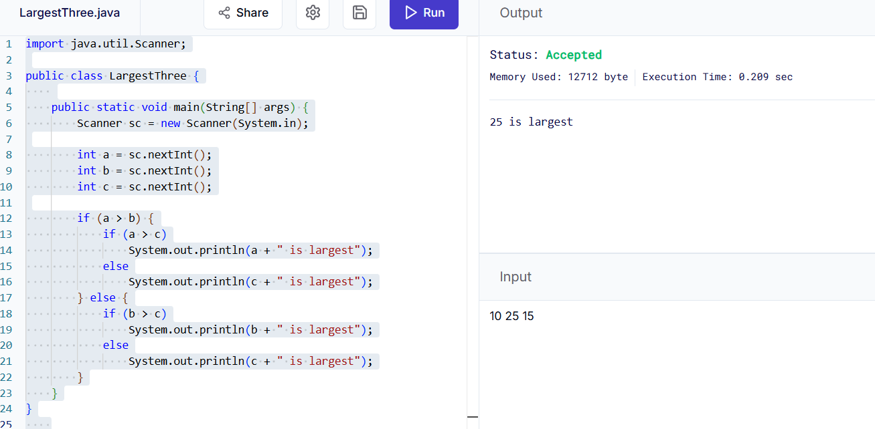

3. Leap Year Program
Write a program to check whether a year is a leap year or not.
Hint:
A leap year is divisible by 4 but not by 100 unless divisible by 400.
Code:
import java.util.Scanner;
public class LeapYear {
public static void main(String[] args) {
Scanner sc = new Scanner(System.in);
int year = sc.nextInt();
if ((year % 4 == 0 && year % 100 != 0) || year % 400 == 0)
System.out.println("Leap Year");
else
System.out.println("Not a Leap Year");
}
}

Screen Shot:
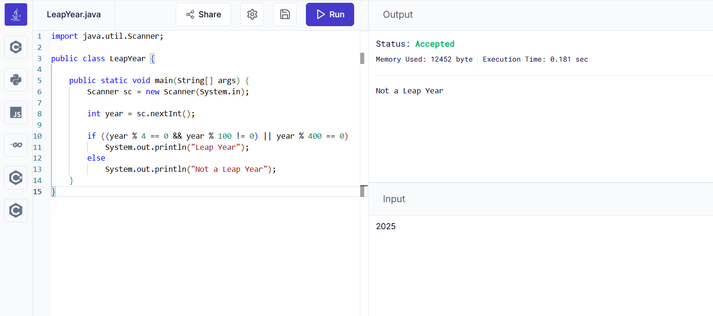

4. Positive, Negative, or Zero
Write a program to check whether a number is positive, negative, or zero.
Code:
import java.util.Scanner;
public class PositiveNegativeZero {
public static void main(String[] args) {
Scanner sc = new Scanner(System.in);
int num = sc.nextInt();
if (num>0)
System.out.println("Positive");
else if (num<0)
System.out.println("Negative");
else
System.out.println("Zero");
}
}

Screen Shot
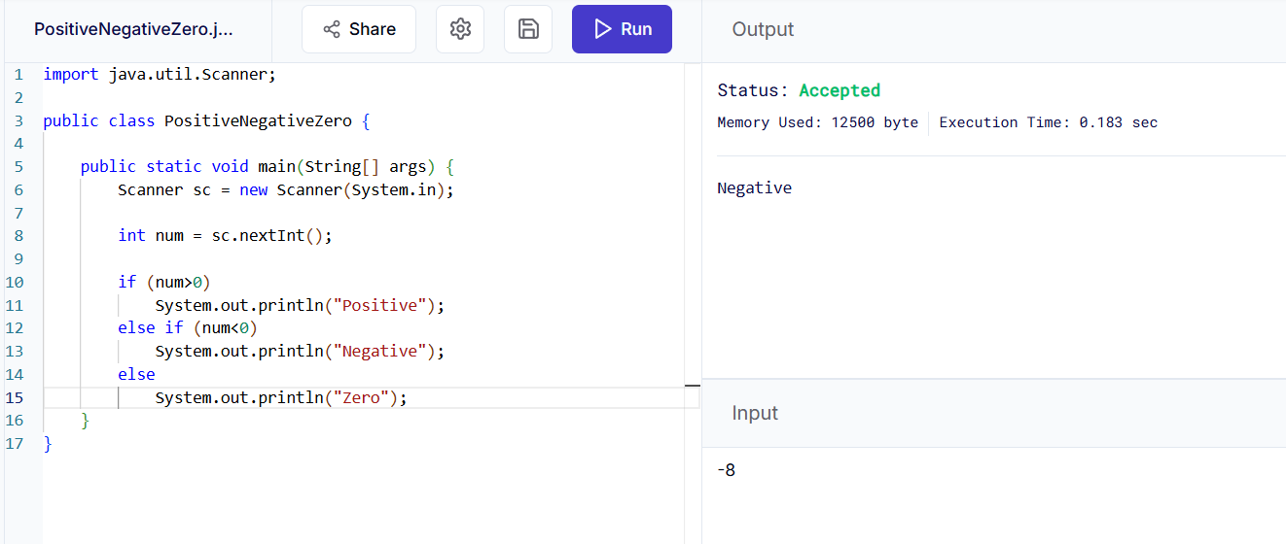

5. Print Numbers from 1 to N
Write a program using a for loop to print numbers from 1 to N.
Example:
Input: 5
Output: 1 2 3 4 5
Code:
import java.util.Scanner;
public class PositiveNegativeZero {
public static void main(String[] args) {
Scanner sc = new Scanner(System.in);
int n = sc.nextInt();
for (int i = 1; i <= n; i++) {
System.out.print(i + " ");
}
}
}
Screen Shot:
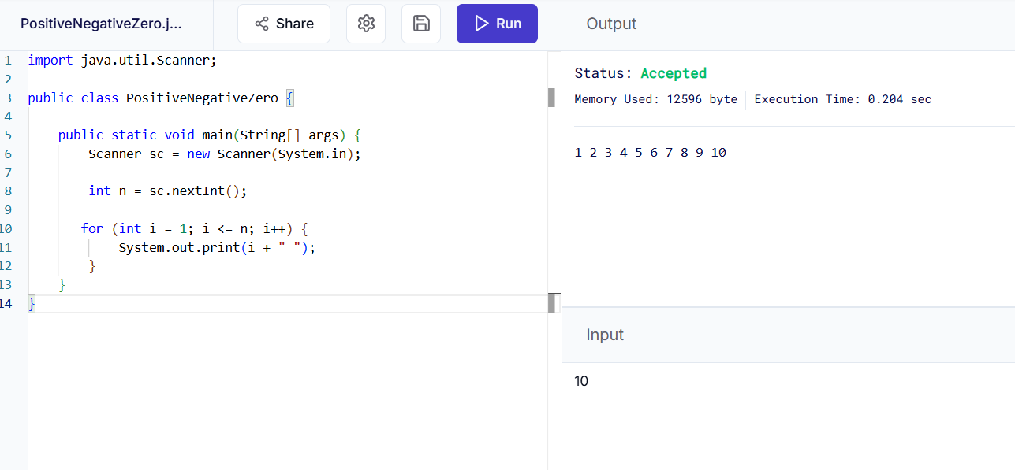

6. Sum of First N Natural Numbers
Write a program using a while loop to calculate the sum of first N natural numbers.
Example:
Input: 5
Output: 15
Code:
import java.util.Scanner;
public class SumNatural {
public static void main(String[] args) {
Scanner sc = new Scanner(System.in);
int n = sc.nextInt();
int sum = 0, i = 1;
while (i <= n) {
sum += i;
i++;
}
System.out.println(sum);
}
}
Screen Shot:
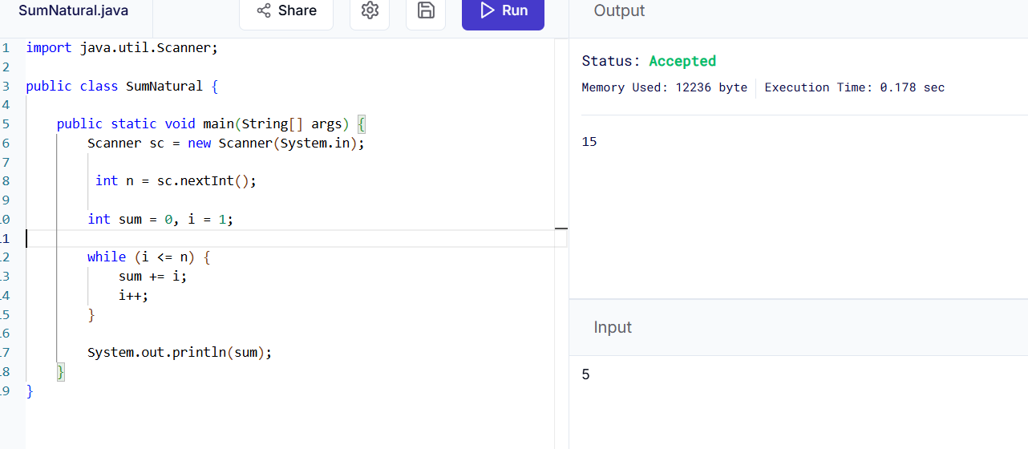

7. Multiplication Table
Write a program to print the multiplication table of a number using a for loop.
Example:
Input: 4
Output:
4 x 1 = 4
4 x 2 = 8
...
4 x 10 = 40
Code:
import java.util.Scanner;
public class MultiplicationTable {
public static void main(String[] args) {
Scanner sc = new Scanner(System.in);
int num = sc.nextInt();
for(int i=1;i<=10;i++){
System.out.println(num+"x"+i+"="+(num*i));
}
}
}
Screen Shot:
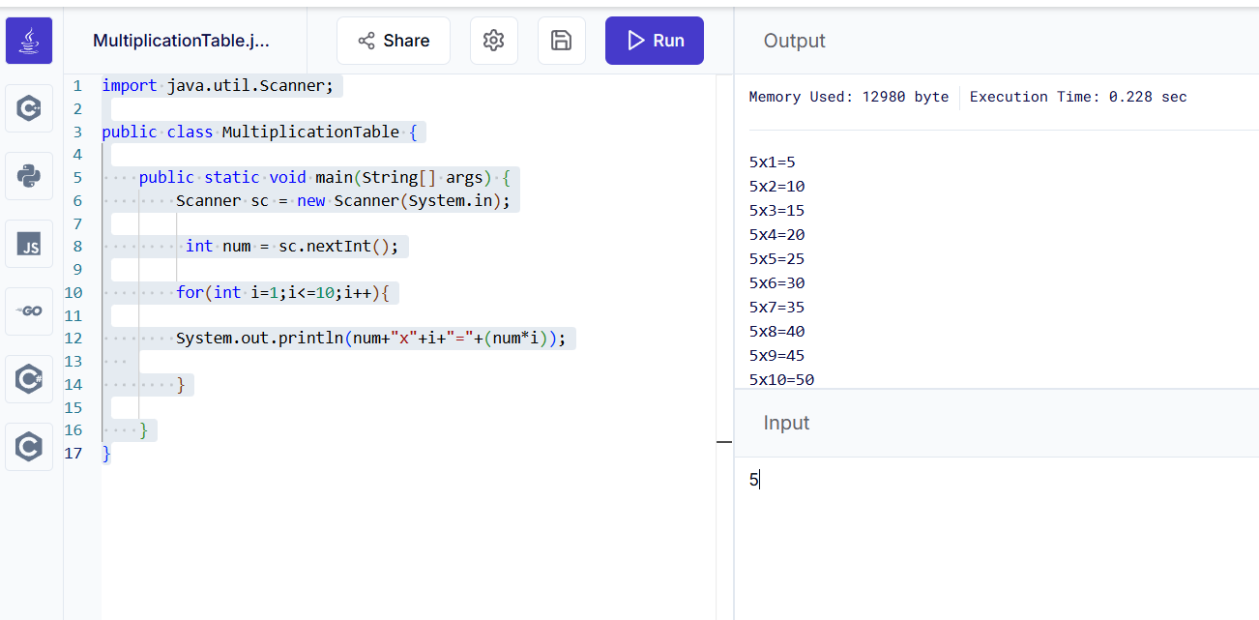
8. Reverse a Number
Write a program using a while loop to reverse a number.
Example:
Input: 1234
Output: 4321
Code:
import java.util.Scanner;
public class ReverseNumber {
public static void main(String[] args) {
Scanner sc = new Scanner(System.in);
int num = sc.nextInt();
int reverse=0;
while(num!=0){
int digit = num%10;
reverse=reverse*10+digit;
num/=10;
}
System.out.println(reverse);
}
}
Screen Shot:
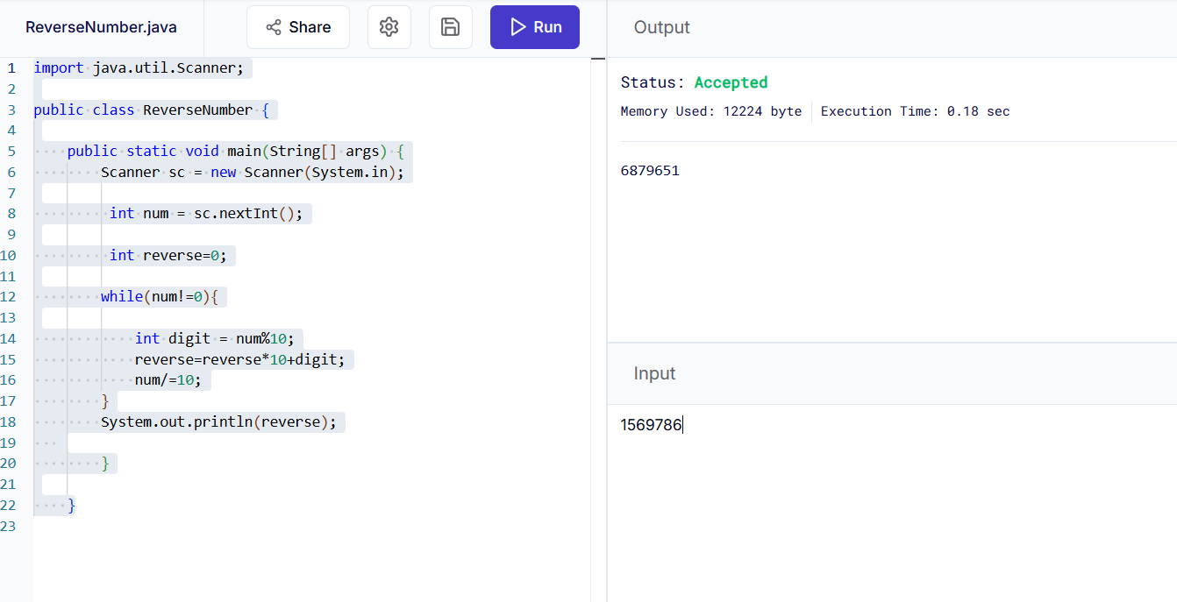
9. Palindrome Number
Write a program to check whether a number is palindrome or not.
Example:
Input: 121
Output: Palindrome
Code:
import java.util.Scanner;
public class Palindrome {
public static void main(String[] args) {
Scanner sc = new Scanner(System.in);
int num = sc.nextInt();
int original=num;
int reverse=0;
while(num!=0){
int digit = num%10;
reverse=reverse*10+digit;
num/=10;
}
if(original==reverse)
System.out.println("Palindrome");
else
System.out.println("Not Palindrome");
}
}
Screen Shot:
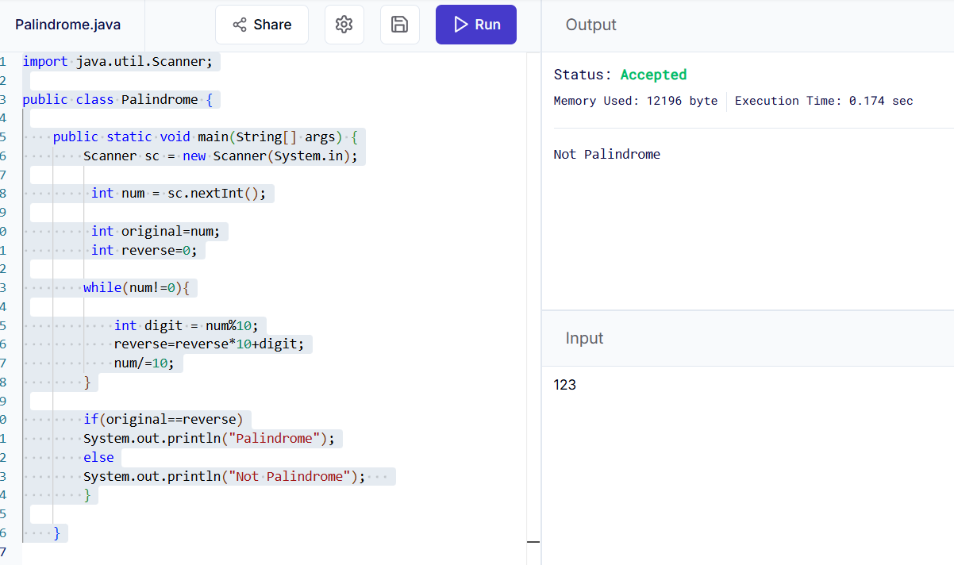
10. Count Digits in a Number
Write a program using a while loop to count the number of digits in an integer.
Example:
Input: 98765
Output: 5
Code:
import java.util.Scanner;
public class CountDigits {
public static void main(String[] args) {
Scanner sc = new Scanner(System.in);
int num = sc.nextInt();
int count=0;
while(num!=0){
count++;
num/=10;
}
System.out.println(count);
}
}
Screen Shot:
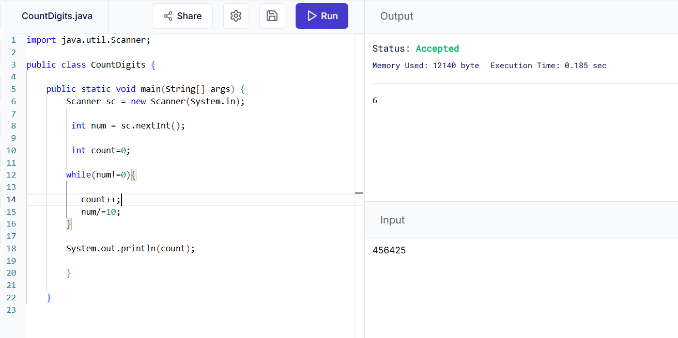

11. Factorial of a Number
Write a program using a for loop to find factorial of a number.
Example:
Input: 5
Output: 120
Code:
import java.util.Scanner;
public class Factorial {
public static void main(String[] args) {
Scanner sc = new Scanner(System.in);
int n = sc.nextInt();
long fact=1;
for(int i=1;i<=n;i++){
fact*=i;
}
System.out.println(fact);
}
}
Screen Shot:

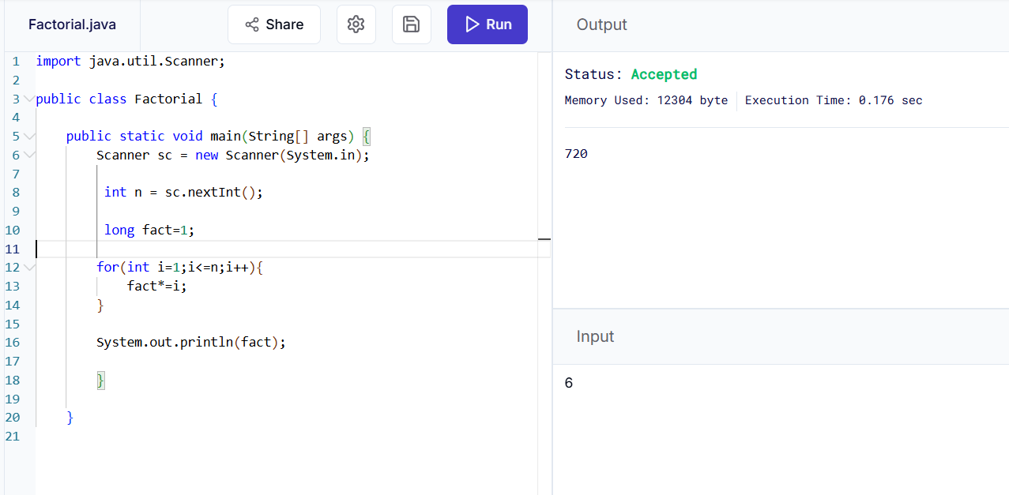
12. Prime Number Check
Write a program to check whether a number is prime or not using loops and if condition.
Example:
Input: 11
Output: Prime
Code:
import java.util.Scanner;
public class PrimeCheck {
public static void main(String[] args) {
Scanner sc = new Scanner(System.in);
int n = sc.nextInt();
boolean isPrime=true;
if (n <= 1)
isPrime = false;
else {
for (int i = 2; i <= n / 2; i++) {
if (n % i == 0) {
isPrime = false;
break;
}
}
}
if (isPrime)
System.out.println("Prime");
else
System.out.println("Not Prime");
}
}

Screen Shot:
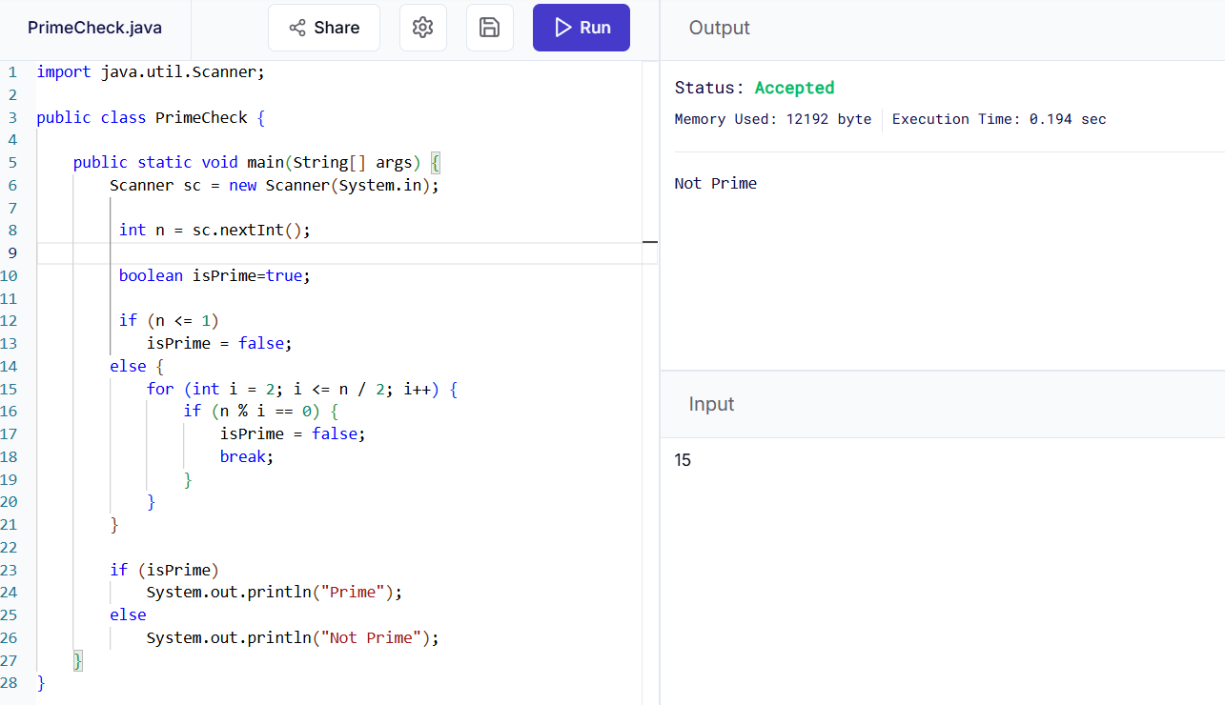
13. Fibonacci Series
Write a program to print Fibonacci series up to N terms using a loop.
Example:
Input: 6
Output: 0 1 1 2 3 5
Code:
import java.util.Scanner;
public class Fibonacci {
public static void main(String[] args) {
Scanner sc = new Scanner(System.in);
int n = sc.nextInt();
int a=0,b=1;
for(int i=1;i<=n;i++){
System.out.println(a + "");
int c=a+b;
a=b;
b=c;
}
}
}
Screen Shot:
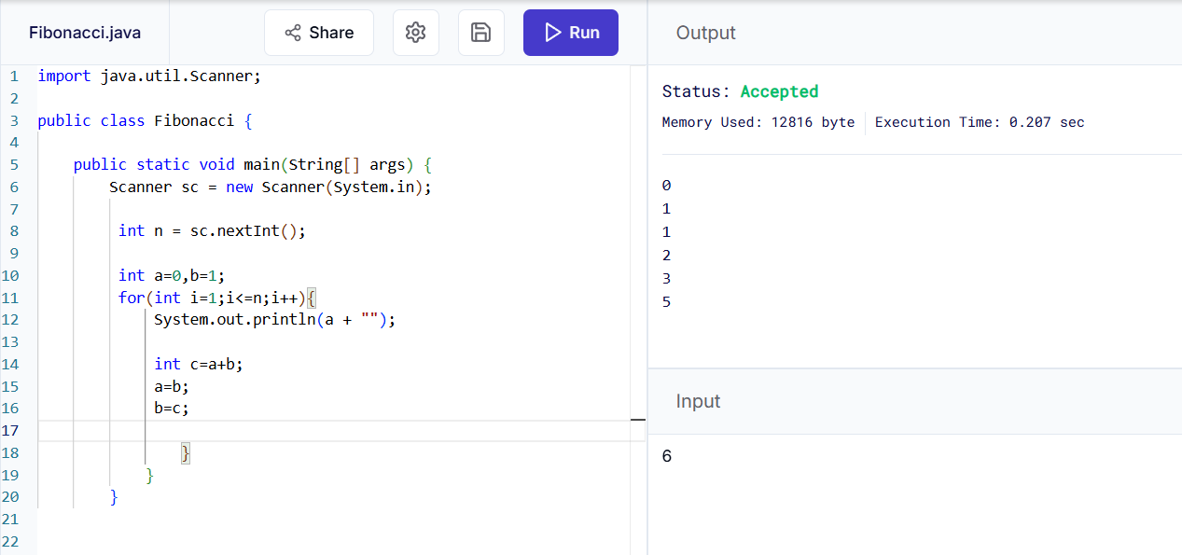

14. Menu-Driven Calculator using do-while
Create a calculator using do-while loop that repeatedly asks the user to:
Add
Subtract
Multiply
Divide
Exit
The program should continue until the user chooses Exit.
Code:
import java.util.Scanner;
public class Calculator {
public static void main(String[] args) {
Scanner sc = new Scanner(System.in);
int choice;
double a,b;
do{
System.out.println("1. Add");
System.out.println("2. Subtract");
System.out.println("3. Multiply");
System.out.println("4. Divide");
System.out.println("5. Exit");
choice=sc.nextInt();
switch(choice){
case 1:
a=sc.nextDouble();
b=sc.nextDouble();
System.out.println("Result="+(a+b));
break;
case 2:
a=sc.nextDouble();
b=sc.nextDouble();
System.out.println("Result="+(a-b));
break;
case 3:
a=sc.nextDouble();
b=sc.nextDouble();
System.out.println("Result="+(a*b));
break;
case 4:
a=sc.nextDouble();
b=sc.nextDouble();
if(b!=0)
System.out.println("Result = " + (a / b));
else
System.out.println("Cannot divide by zero");
break;
case 5:
System.out.println("Exiting...");
break;
default:
System.out.println("Invalid Choice");
}
} while (choice != 5);
}
}

Screen Shot:
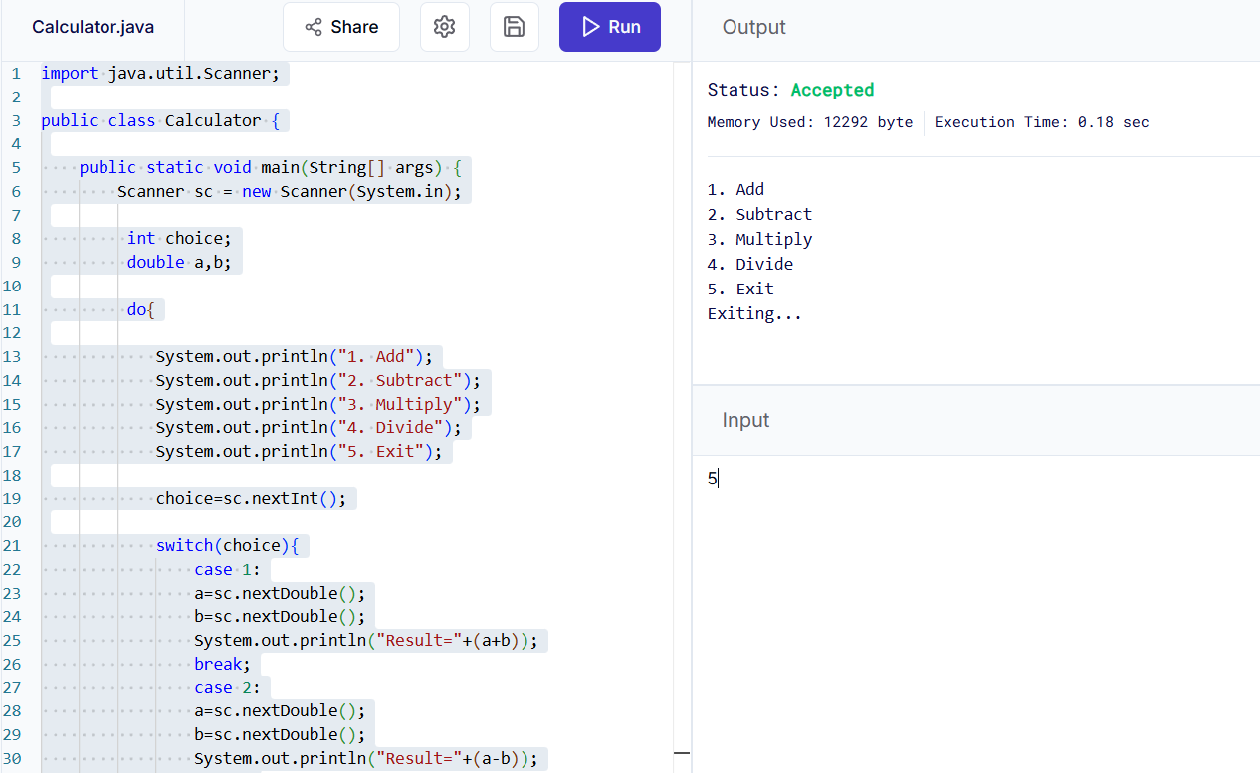
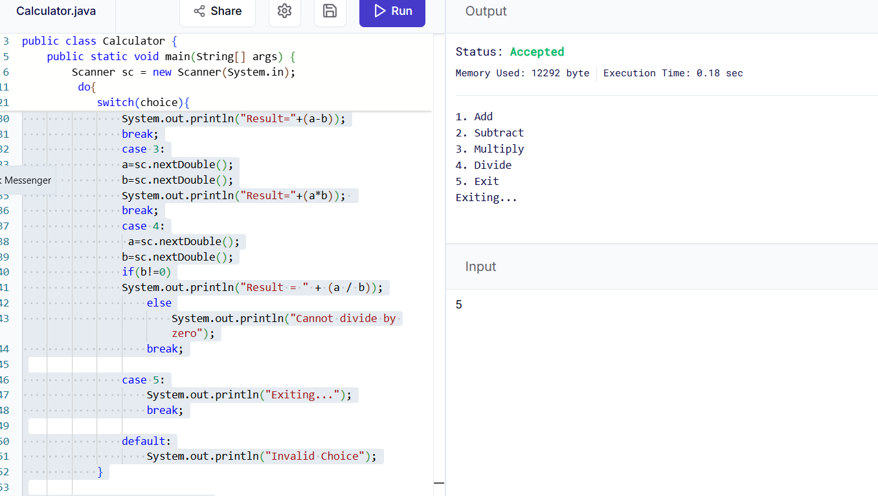

15. Pattern Printing
Write a program using nested for loops to print the following pattern:
*
**
***
****
*****
Code:
public class Pattern {
public static void main(String[] args) {
for(int i=1;i<=5;i++){
for(int j=1;j<=i;j++){
System.out.print("*");
}
System.out.println();
}
}
}
Screen Shot:
